# SENSORS

* Each of the sensors was tested on the breadboard with the use of the required software and the microcontroller. The accuracy of the data obtained from each sensor was checked.
* Then the sensor tests were carried out in a combined manner.

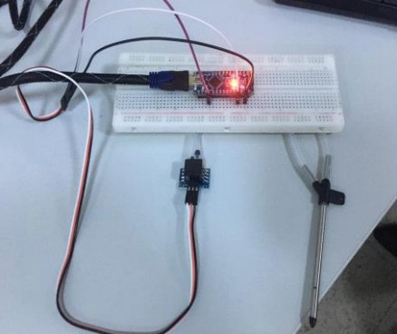

# CDH

* The communication between the microcontroller and the sensors was tested.
* The communication between the receiver and transmitter XBee were tested using the XCTU Software for the competition distance requirements (600-800 meters).
* The gain test of the antenna was tested using the XCTU Software.
* The data transmission altitude requirement (750 meters) in competition will be tested via drone. Then, the data transmission speed and the accuracy of the data sent to the ground station will be checked.

# EPS

Prototype circuit was installed on the perforated plate and breadboard. It was checked if it works with the required power supply.

The total current of the system was measured. Calculated and measured values were compared. The melt of fishline circuit was installed and the break time of the melt was measured.

The MOSFET used in circuit was triggered with 3.3V to check its operation. It will be checked whether there is a short circuit on the PCB.

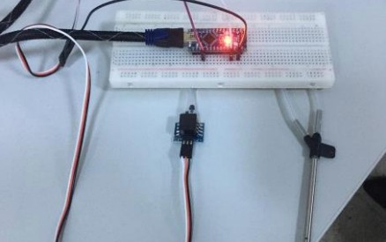

Caption

# Radio Communication

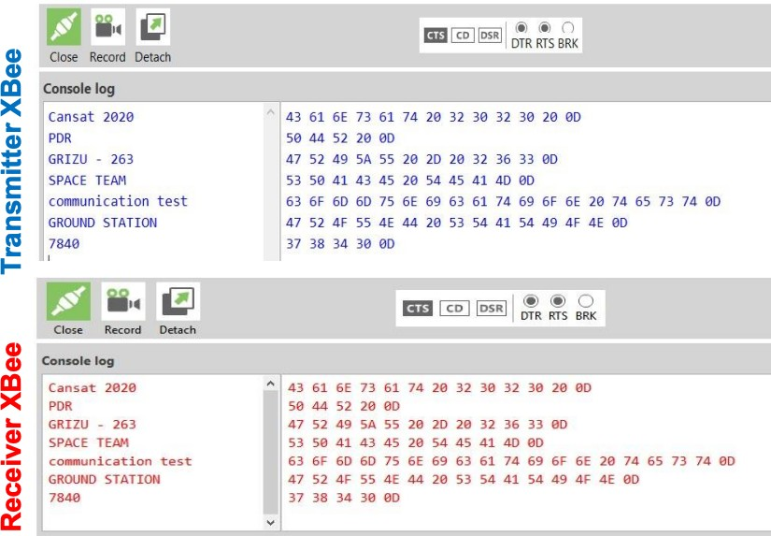

* The XBees setting was done over XCTU software. NETID/PANID and baud rate accuracy was checked.
* The XBee communicates in unicast mode. XBees do not broadcast, the XBees only communicate with each other.
* Data received from the sensors on the circuit will be transmitted to the ground station via XBee. The data will be checked from the ground station interface.
* The sufficiency of the computer battery was tested for 2 hours.
* We continue the tests as we have started at the PDR stage.

# MECHANICAL

* Delta wing folding mechanism was tested (hinge, rotating joint, stretched fabric elastic and telescopic system).
* The sufficiency of the delta wings for descenting was tested at different altitudes.
* The CanSat's mechanical tests will be checked (separation, drop and fit check etc.).
* The payload release mechanism will be tested with FSW.
* The CanSat's subsystems durability before and after the test flights will be checked.
* The CanSat will be checked for the given environmental test requirements.
* Thanks to the folding mechanism designers in our team. It fits well into the container.
* The camera stabilization will be achieved by actively controlling payload with rudder and elevator using servo motors

# Decent Control

* The installed electronic circuit will be placed in the payload and it will be tested at 450 meters via the drone.
* The payload’s delta wings will be tested for gliding in a circular pattern with a radius of 250 meters from 450 meters to above 100 meters (actively controlled for one minute). Its aerodynamic suitability will also be checked during the test.
* Active control of the payload will be provided with rudder and elevator using the servo motors. The opening of the payload’s parachute will be tested at an altitude above 100 meters.

# FSW

* The accuracy of the data get from the each sensors were checked (particulate/dust, air speed, GPS location, temperature, pressure, etc.).
* Sub-systems were tested (release mechanisms, parachute opening, communication, etc.).
* Data recovery algorithms were tested in case of microcontroller reset.
* The sequence of the data transmission to the ground station will be checked for consistency in the appropriate order.

